Joint Distributions
Topic 5 — Two Draws Without Replacement
Statistics · Midterm Team Project (Weeks 1–7) · Written report
Team: 5 · Lecture stream: 3 pm-4.50 pm
Contribution page. Each section of the report has an owner who can reproduce every derivation of that section at the board.
§ | Section (project part) | Content | Owner
1 | The joint model (Part A) | experiment, joint pmf and cdf, validity (A1); marginals and conditionals (A2) | A1: Ильясов Шадияр Нурланович  · A2: Жиликбай Жібек Муктарқызы
2 | Moments and dependence (Part B) | E, Var, Cov, ρ, conditional expectation, total expectation and variance | Иманғали Ерден Қайратұлы
3 | Independence and sums (Part C) | dependence, exchangeability, S = X₁ + X₂ is Hypergeometric(N, K, 2) | Каримов Султанмурат Алишерович
4 | Transformations and special results (Part D) | n draws, finite-population correction, binomial limit | Каримов Ералы Ермекұлы
5 | Examples and interesting facts (Part E) | E1 worked example · E2 data example · E3 facts · summary card | E1: Ербулат Дина Асқарқызы  · E2, E3: Ерханұлы Ернұр, Иман Ернұр Бахтиярұлы
Notation. Capital letters are random variables, lowercase letters are their values. The urn has $N$ balls, $K$ of them red; $p=K/N$ and $q=1-p$. $X_{1},X_{2}$ are the indicators that the first and the second ball are red; $p\left(x_{1},x_{2}\right)$ is the joint pmf and $p_{X_{1}},p_{X_{2}}$ the marginals. $E$, $Var$, $Cov$, $ρ$ and $σ$ are population quantities. For data we write $\overset{‾}{x}$, $s^{2}$, $s_{xy}$ and $r$ for sample statistics.
Summary of results. Both draws are Bernoulli($p$) with the same mean and variance, but they are dependent: $Cov\left(X_{1},X_{2}\right)=-\frac{K\left(N-K\right)}{N^{2}\left(N-1\right)}$ and $ρ=-\frac{1}{N-1}$. The number of red balls $S=X_{1}+X_{2}$ is Hypergeometric($N$, $K$, 2) with $Var\left(S\right)=\frac{2pq\left(N-2\right)}{N-1}$. For $n$ draws, $Var\left(S_{n}\right)=npq \frac{N-n}{N-1}$, and as $N→∞$ the model becomes Binomial($n$, $p$).

1. The joint model (Part A)

1.1 The random experiment
An urn contains $N≥2$ balls, $K$ of them red and $N-K$ blue ($0≤K≤N$). Two balls are drawn one after the other without replacement, and at every step each remaining ball is equally likely to be chosen. Define
$$X_{1}=\left\{\begin{matrix}1 & \text{first ball red} \\ 0 & \text{otherwise}\end{matrix}\right. X_{2}=\left\{\begin{matrix}1 & \text{second ball red} \\ 0 & \text{otherwise.}\end{matrix}\right.$$
The sample space is the set of ordered pairs of distinct balls. It has $N\left(N-1\right)$ equally likely outcomes: $N$ choices for the first ball and $N-1$ for the second. The support of $\left(X_{1},X_{2}\right)$ is the four points $\{0,1\}^{2}$, a rectangle.

1.2 Joint pmf, derived by counting
We count the ordered pairs of distinct balls that give each colour pattern.
- (red, red): $K$ choices for the first ball and $K-1$ for the second, so $K\left(K-1\right)$ pairs.
- (red, blue): $K\left(N-K\right)$ pairs. (blue, red): $\left(N-K\right)K$ pairs.
- (blue, blue): $\left(N-K\right)\left(N-K-1\right)$ pairs.
Dividing by the $N\left(N-1\right)$ equally likely outcomes gives the joint pmf. The same result follows from the multiplication rule $P\left(X_{1}=x_{1},X_{2}=x_{2}\right)=P\left(X_{1}=x_{1}\right) P\left(X_{2}=x_{2}∣X_{1}=x_{1}\right)$; for example $P\left(1,1\right)=\frac{K}{N}⋅\frac{K-1}{N-1}$.
Table 1. Joint pmf and marginals (the marginals are derived in 1.4).
$$p\left(x_{1},x_{2}\right)$$ | $$x_{2}=0$$ | $$x_{2}=1$$ | $$p_{X_{1}}\left(x_{1}\right)$$
$$x_{1}=0$$ | $$\frac{\left(N-K\right)\left(N-K-1\right)}{N\left(N-1\right)}$$ | $$\frac{K\left(N-K\right)}{N\left(N-1\right)}$$ | $$\frac{N-K}{N}$$
$$x_{1}=1$$ | $$\frac{K\left(N-K\right)}{N\left(N-1\right)}$$ | $$\frac{K\left(K-1\right)}{N\left(N-1\right)}$$ | $$\frac{K}{N}$$
$$p_{X_{2}}\left(x_{2}\right)$$ | $$\frac{N-K}{N}$$ | $$\frac{K}{N}$$ | 1
For $N=7$, $K=3$ the table is $p\left(0,0\right)=p\left(0,1\right)=p\left(1,0\right)=2/7$ and $p\left(1,1\right)=1/7$ (Figure 1).
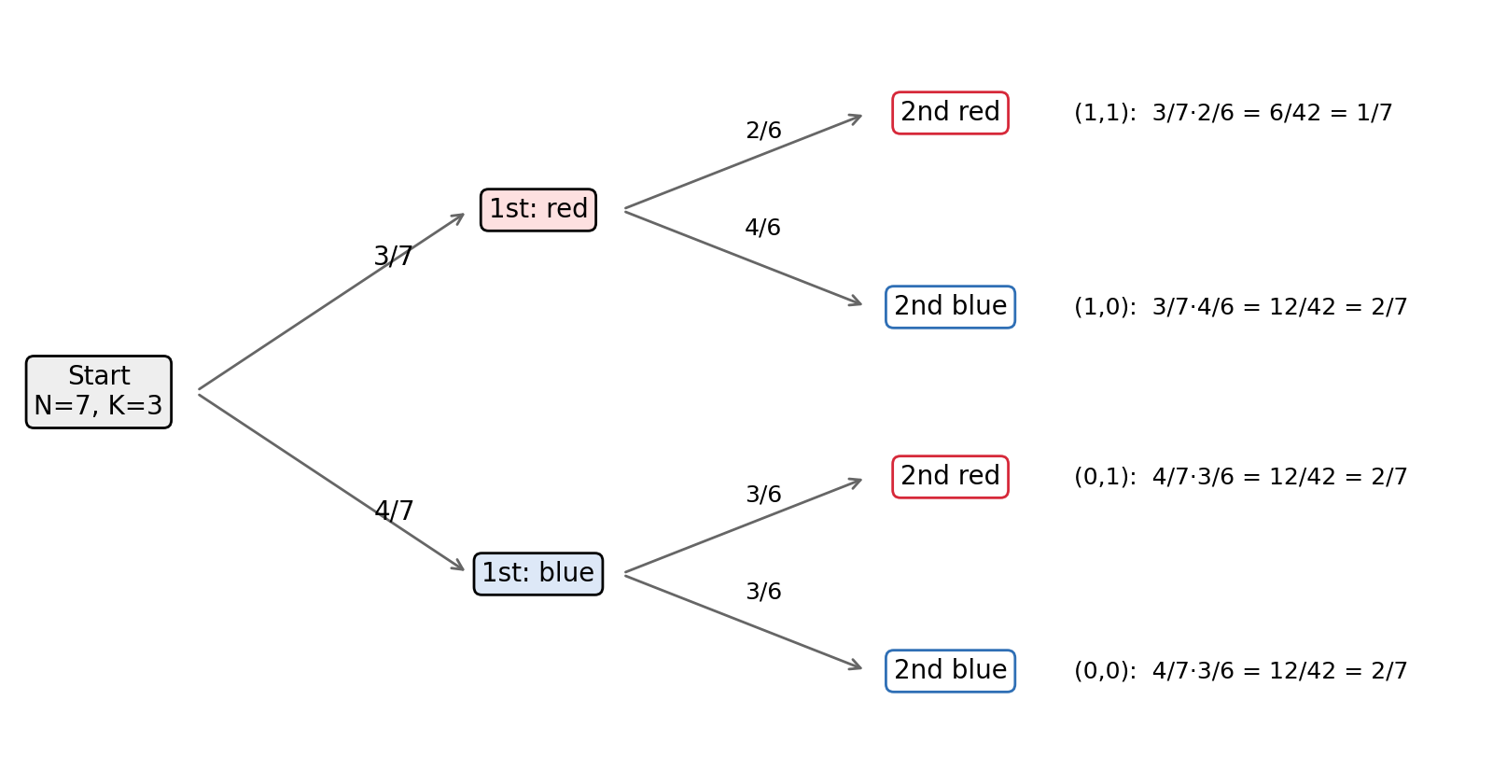
Figure 1. Probability tree for N = 7, K = 3. Each leaf is a product of the branch probabilities (multiplication rule).
Validity. Every entry is a product of non-negative integers divided by $N\left(N-1\right)>0$, so $p≥0$. (If $K=0$ or $K=1$ then $K\left(K-1\right)=0$, which is correct: two red balls cannot be drawn.) The total is
x1,x2​px1,x2=KK-1+2KN-K+N-KN-K-1NN-1=K2-K+2KN-2K2+N2-2NK+K2-N+KNN-1=N2-NNN-1=1.
Check: for $N=7$, $K=3$: $\frac{6+12+12+12}{42}=1$.

1.3 Joint cdf
The cdf $F\left(x_{1},x_{2}\right)=P\left(X_{1}≤x_{1},X_{2}≤x_{2}\right)$ is a step function that is $0$ if $x_{1}<0$ or $x_{2}<0$ and $1$ if $x_{1}≥1$ and $x_{2}≥1$. In between it is determined by three values:
$$F\left(0,0\right)=p\left(0,0\right)=\frac{\left(N-K\right)\left(N-K-1\right)}{N\left(N-1\right)}, F\left(0,1\right)=F\left(1,0\right)=p\left(0,0\right)+p\left(0,1\right)=\frac{N-K}{N}.$$
The second value follows from $p\left(0,0\right)+p\left(0,1\right)=\frac{\left(N-K\right) \left[\left(N-K-1\right)+K\right]}{N\left(N-1\right)}=\frac{N-K}{N}$. Check: for $N=7$, $K=3$: $F\left(0,0\right)=\frac{2}{7}$, $F\left(0,1\right)=F\left(1,0\right)=\frac{4}{7}$, $F\left(1,1\right)=1$.

1.4 Marginal distributions (derived by summation)
The marginal pmf of $X_{1}$ is obtained by summing the joint pmf over $x_{2}$:
$$p_{X_{1}}\left(1\right)=p\left(1,0\right)+p\left(1,1\right)=\frac{K\left(N-K\right)+K\left(K-1\right)}{N\left(N-1\right)}=\frac{K\left(N-1\right)}{N\left(N-1\right)}=\frac{K}{N}.$$
The marginal pmf of $X_{2}$ sums over $x_{1}$. Because the two mixed cells are equal, the sum has the same value:
$$p_{X_{2}}\left(1\right)=p\left(0,1\right)+p\left(1,1\right)=\frac{K\left(N-K\right)+K\left(K-1\right)}{N\left(N-1\right)}=\frac{K}{N}.$$
Hence $p_{X_{1}}\left(0\right)=p_{X_{2}}\left(0\right)=\frac{N-K}{N}$, and $X_{1}$ and $X_{2}$ are both Bernoulli($K/N$). The second ball has the same marginal distribution as the first even though the draws are dependent (see 1.5). The reason is symmetry: if we have not looked at the first ball, nothing distinguishes the second position from the first. Check: $N=7$, $K=3$: row sums $\frac{2}{7}+\frac{1}{7}=\frac{3}{7}$ and column sums $\frac{2}{7}+\frac{1}{7}=\frac{3}{7}$.

1.5 Conditional distributions (derived from the definition)
For $p_{X_{1}}\left(x_{1}\right)>0$ the conditional pmf is $P\left(X_{2}=x_{2}∣X_{1}=x_{1}\right)=p\left(x_{1},x_{2}\right)/p_{X_{1}}\left(x_{1}\right)$. Dividing row 1 of Table 1 by $K/N$ and row 0 by $\left(N-K\right)/N$ gives
$$P\left(X_{2}=1∣X_{1}=1\right)=\frac{K\left(K-1\right)/\left[N\left(N-1\right)\right]}{K/N}=\frac{K-1}{N-1}, P\left(X_{2}=1∣X_{1}=0\right)=\frac{K\left(N-K\right)/\left[N\left(N-1\right)\right]}{\left(N-K\right)/N}=\frac{K}{N-1}.$$
The complementary probabilities are $P\left(X_{2}=0∣X_{1}=1\right)=\frac{N-K}{N-1}$ and $P\left(X_{2}=0∣X_{1}=0\right)=\frac{N-K-1}{N-1}$; each pair sums to 1. Since the joint pmf is symmetric in $\left(x_{1},x_{2}\right)$, the same calculation with the roles exchanged gives the conditionals of $X_{1}$ given $X_{2}$:
$$P\left(X_{1}=1∣X_{2}=1\right)=\frac{K-1}{N-1}, P\left(X_{1}=1∣X_{2}=0\right)=\frac{K}{N-1}.$$
Interpretation. After a red first ball, $N-1$ balls remain and only $K-1$ are red. After a blue first ball, all $K$ red balls remain among $N-1$. The ordering $\frac{K-1}{N-1}<\frac{K}{N}<\frac{K}{N-1}$ holds for $0<K<N$: the first inequality is equivalent to $-N<-K$ and the second to $N-1<N$. The conditional pmf of $X_{2}$ depends on $x_{1}$, while the marginal does not, so the draws are dependent (formally shown in Section 3). Averaging the conditionals with weights $\frac{K}{N}$ and $\frac{N-K}{N}$ returns $\frac{K}{N}$ (law of total probability, Section 2.4). Check: for $N=7$, $K=3$: $\frac{2}{6}=\frac{1}{3}$ after red, $\frac{3}{6}=\frac{1}{2}$ after blue, and $\frac{3}{7}$ with no information.

2. Moments and dependence (Part B)

2.1 Expectation and variance
An indicator satisfies $E\left(X_{i}\right)=P\left(X_{i}=1\right)$. By the marginals of Section 1.4,
$$E\left(X_{1}\right)=E\left(X_{2}\right)=\frac{K}{N}=p.$$
Because $X_{i}∈\{0,1\}$ we have $X_{i}^{2}=X_{i}$, so $E\left(X_{i}^{2}\right)=p$ and
$$Var\left(X_{i}\right)=E\left(X_{i}^{2}\right)-{\left[E\left(X_{i}\right)\right]}^{2}=p-p^{2}=pq=\frac{K\left(N-K\right)}{N^{2}}.$$
Check against the joint distribution: EX2=x1,x2​x2 px1,x2=p0,1+p1,1=KN, the same value.

2.2 E(X₁X₂), covariance and correlation
The product $X_{1}X_{2}$ equals 1 only when both balls are red, so
$$E\left(X_{1}X_{2}\right)=p\left(1,1\right)=\frac{K\left(K-1\right)}{N\left(N-1\right)}.$$
By the definition $Cov\left(X_{1},X_{2}\right)=E\left(X_{1}X_{2}\right)-E\left(X_{1}\right)E\left(X_{2}\right)$ and a common denominator $N^{2}\left(N-1\right)$:
$$\begin{matrix}Cov\left(X_{1},X_{2}\right) & =\frac{K\left(K-1\right)}{N\left(N-1\right)}-\frac{K^{2}}{N^{2}}=\frac{K \left[N\left(K-1\right)-K\left(N-1\right)\right]}{N^{2}\left(N-1\right)} \\ & =\frac{K\left(K-N\right)}{N^{2}\left(N-1\right)}=-\frac{K\left(N-K\right)}{N^{2}\left(N-1\right)}=-\frac{pq}{N-1}.\end{matrix}$$
Since $σ_{X_{1}}σ_{X_{2}}=pq$, the correlation is
$$ρ\left(X_{1},X_{2}\right)=\frac{Cov\left(X_{1},X_{2}\right)}{σ_{X_{1}}σ_{X_{2}}}=\frac{-pq/\left(N-1\right)}{pq}=-\frac{1}{N-1} \left(0<K<N\right).$$
Interpretation. The covariance is negative because the draws compete for the same $K$ red balls: a red first ball removes one of them. The correlation does not depend on $K$, only on the size of the urn. It tends to 0 as $N→∞$ because removing one ball from a large urn hardly changes its composition (Figure 2, left). It is never exactly 0 for a finite urn, so the draws are never independent. If $K=0$ or $K=N$ then $pq=0$: the colours are certain and $ρ$ is undefined.
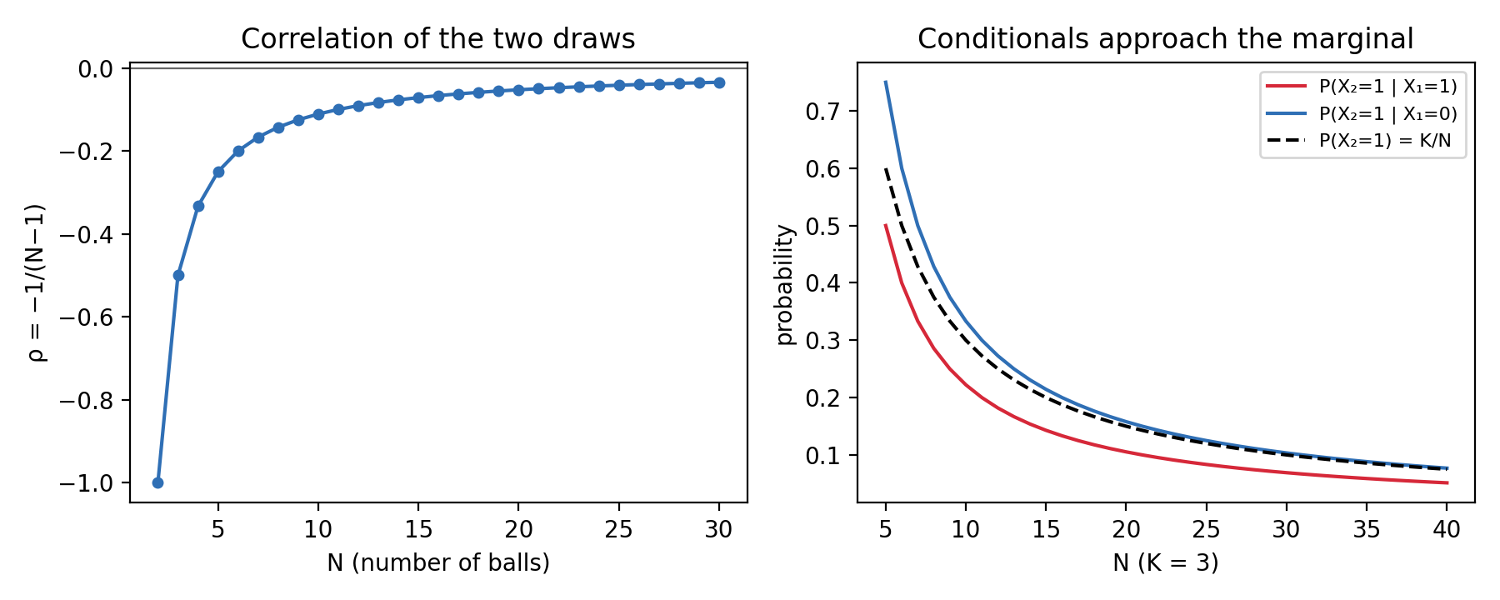
Figure 2. Left: ρ = −1/(N−1) as a function of N. Right: the conditional probabilities of a red second ball (K = 3) approach the marginal K/N as N grows.

2.3 Conditional expectations
For an indicator the conditional expectation is a conditional probability. From Section 1.5,
$$E\left(X_{2}∣X_{1}=1\right)=\frac{K-1}{N-1}, E\left(X_{2}∣X_{1}=0\right)=\frac{K}{N-1}, \text{i.e.} E\left(X_{2}∣X_{1}=x\right)=\frac{K-x}{N-1}, x∈\{0,1\}.$$
This is a linear function of $x$ with slope $-\frac{1}{N-1}$, which equals $ρ$ because $σ_{X_{1}}=σ_{X_{2}}$ (slope $=Cov/Var\left(X_{1}\right)=-\frac{pq}{\left(N-1\right) pq}$). Each red ball already drawn lowers the expected number of reds still to come by $\frac{1}{N-1}$.

2.4 Laws of total expectation and total variance
Total expectation. $E\left[E\left(X_{2}∣X_{1}\right)\right]=\frac{K}{N}⋅\frac{K-1}{N-1}+\frac{N-K}{N}⋅\frac{K}{N-1}=\frac{K \left[\left(K-1\right)+\left(N-K\right)\right]}{N\left(N-1\right)}=\frac{K}{N}=E\left(X_{2}\right)$.
Total variance. The conditional variances of a Bernoulli variable are $Var\left(X_{2}∣X_{1}=1\right)=\frac{\left(K-1\right)\left(N-K\right)}{{\left(N-1\right)}^{2}}$ and $Var\left(X_{2}∣X_{1}=0\right)=\frac{K\left(N-K-1\right)}{{\left(N-1\right)}^{2}}$. Then
$$E\left[Var\left(X_{2}∣X_{1}\right)\right]=\frac{K}{N}⋅\frac{\left(K-1\right)\left(N-K\right)}{{\left(N-1\right)}^{2}}+\frac{N-K}{N}⋅\frac{K\left(N-K-1\right)}{{\left(N-1\right)}^{2}}=\frac{K\left(N-K\right)\left(N-2\right)}{N{\left(N-1\right)}^{2}},$$
$$Var\left[E\left(X_{2}∣X_{1}\right)\right]=Var​\left(\frac{K-X_{1}}{N-1}\right)=\frac{Var\left(X_{1}\right)}{{\left(N-1\right)}^{2}}=\frac{K\left(N-K\right)}{N^{2}{\left(N-1\right)}^{2}}.$$
Adding, with common denominator $N^{2}{\left(N-1\right)}^{2}$ and numerator $K\left(N-K\right) \left[N\left(N-2\right)+1\right]=K\left(N-K\right){\left(N-1\right)}^{2}$:
$$E\left[Var\left(X_{2}∣X_{1}\right)\right]+Var\left[E\left(X_{2}∣X_{1}\right)\right]=\frac{K\left(N-K\right)}{N^{2}}=pq=Var\left(X_{2}\right). ✓$$

2.5 Checks
Numerical check ($N=7$, $K=3$). $p=\frac{3}{7}$, $pq=\frac{12}{49}$, $E\left(X_{1}X_{2}\right)=\frac{3⋅2}{7⋅6}=\frac{1}{7}$. Then $Cov=\frac{1}{7}-\frac{9}{49}=-\frac{2}{49}$, which agrees with $-\frac{pq}{N-1}=-\frac{12/49}{6}$, and $ρ=\frac{-2/49}{12/49}=-\frac{1}{6}=-\frac{1}{7-1}$.
Extreme case ($N=2$, $K=1$). Then $X_{2}=1-X_{1}$ exactly, a perfect negative linear relation, and the formula gives $ρ=-1$.
Range. $-1≤-\frac{1}{N-1}≤0$ for all $N≥2$.

3. Independence and sums (Part C)

3.1 The pair is dependent
Criterion. $X_{1}$ and $X_{2}$ are independent if and only if $p\left(x_{1},x_{2}\right)=p_{X_{1}}\left(x_{1}\right) p_{X_{2}}\left(x_{2}\right)$ for all points of support, and the support must be a rectangle. The support $\{0,1\}^{2}$ is a rectangle, so we test the factorisation. At $\left(1,1\right)$:
$$p\left(1,1\right)-p_{X_{1}}\left(1\right) p_{X_{2}}\left(1\right)=\frac{K\left(K-1\right)}{N\left(N-1\right)}-\frac{K^{2}}{N^{2}}=-\frac{K\left(N-K\right)}{N^{2}\left(N-1\right)}≠0 \left(0<K<N\right).$$
The factorization fails, so the variables are dependent. The difference equals $Cov\left(X_{1},X_{2}\right)$, as it must for two indicators: for 0–1 variables, $Cov=0$ holds exactly when $p\left(1,1\right)=p_{X_{1}}\left(1\right)p_{X_{2}}\left(1\right)$, and this forces the other three cells to factorise as well (Topic 1). The same conclusion comes from the conditionals: $P\left(X_{2}=1∣X_{1}=1\right)=\frac{K-1}{N-1}≠\frac{K}{N}=P\left(X_{2}=1\right)$. Check: $N=7$, $K=3$: $p\left(1,1\right)=\frac{1}{7}<\frac{9}{49}$.

3.2 The pair is exchangeable
Definition. $\left(X_{1},X_{2}\right)$ is exchangeable if swapping the two variables does not change the joint distribution: $p\left(x_{1},x_{2}\right)=p\left(x_{2},x_{1}\right)$ for all $x_{1},x_{2}$.
Proof. The cells $\left(0,0\right)$ and $\left(1,1\right)$ are unchanged by a swap. For the mixed cells, $p\left(1,0\right)=\frac{K\left(N-K\right)}{N\left(N-1\right)}=p\left(0,1\right)$. Hence the joint pmf is symmetric. $▫$
Two consequences: both draws have the same marginal (Section 1.4), and the order of the draws carries no information. Exchangeability is weaker than independence: independent identically distributed variables are exchangeable, but the converse is false, and the urn without replacement is the standard example of exchangeable but dependent variables. The dependence is the price of removing the ball. (Exchangeability is a statement about the draws as labelled by position; it is also the reason the second ball “has the same chance” as the first before the first is seen.)

3.3 The sum $S=X_{1}+X_{2}$ by direct counting
$S$ is the number of red balls in the two draws and takes values in $\{0,1,2\}$. We add the cells of Table 1 that give each value:
$$P\left(S=0\right)=p\left(0,0\right)=\frac{\left(N-K\right)\left(N-K-1\right)}{N\left(N-1\right)}, P\left(S=1\right)=p\left(1,0\right)+p\left(0,1\right)=\frac{2K\left(N-K\right)}{N\left(N-1\right)}, P\left(S=2\right)=p\left(1,1\right)=\frac{K\left(K-1\right)}{N\left(N-1\right)}.$$
Identification. The Hypergeometric($N$, $K$, $n$) pmf is $P\left(S=s\right)=\left({K \atop s}\right)\left({N-K \atop n-s}\right)/\left({N \atop n}\right)$. With $n=2$ and $\left({N \atop 2}\right)=\frac{N\left(N-1\right)}{2}$:
$$s=2: \frac{\left({K \atop 2}\right)}{\left({N \atop 2}\right)}=\frac{K\left(K-1\right)}{N\left(N-1\right)}, s=1: \frac{K\left(N-K\right)}{N\left(N-1\right)/2}=\frac{2K\left(N-K\right)}{N\left(N-1\right)}, s=0: \frac{\left({N-K \atop 2}\right)}{\left({N \atop 2}\right)}=\frac{\left(N-K\right)\left(N-K-1\right)}{N\left(N-1\right)}.$$
The three expressions coincide with the counted probabilities, so $S∼\text{Hypergeometric}\left(N,K,2\right)$. The probabilities add to 1 by Vandermonde’s identity s​KsN-K2-s=N2, which is Section 1.2 again. Check: for $N=7$, $K=3$: $P\left(S=0,1,2\right)=\frac{2}{7},\frac{4}{7},\frac{1}{7}$.

3.4 Mean and variance of $S$
By linearity, $E\left(S\right)=E\left(X_{1}\right)+E\left(X_{2}\right)=2p$. With the covariance term of Section 2.2,
$$Var\left(S\right)=Var\left(X_{1}\right)+Var\left(X_{2}\right)+2Cov\left(X_{1},X_{2}\right)=2pq-\frac{2pq}{N-1}=\frac{2pq \left(N-2\right)}{N-1}.$$
Check against the distribution of $S$ derived above. From the pmf, $E\left(S\right)=P\left(S=1\right)+2P\left(S=2\right)=\frac{2K\left(N-K\right)+2K\left(K-1\right)}{N\left(N-1\right)}=\frac{2K}{N}$ and $E\left(S^{2}\right)=P\left(S=1\right)+4P\left(S=2\right)=\frac{2K\left(N+K-2\right)}{N\left(N-1\right)}$. Then
$$Var\left(S\right)=\frac{2K\left(N+K-2\right)}{N\left(N-1\right)}-\frac{4K^{2}}{N^{2}}=\frac{2K \left[N^{2}-NK-2N+2K\right]}{N^{2}\left(N-1\right)}=\frac{2K\left(N-K\right)\left(N-2\right)}{N^{2}\left(N-1\right)}=\frac{2pq\left(N-2\right)}{N-1}. ✓$$
Check against the hypergeometric variance formula $n pq \frac{N-n}{N-1}$ with $n=2$: $2pq \frac{N-2}{N-1}$, identical. For $N=7$, $K=3$ the pmf $\left(\frac{2}{7},\frac{4}{7},\frac{1}{7}\right)$ gives $E\left(S\right)=\frac{6}{7}$, $E\left(S^{2}\right)=\frac{8}{7}$ and $Var\left(S\right)=\frac{8}{7}-\frac{36}{49}=\frac{20}{49}$; the formula gives $2⋅\frac{12}{49}⋅\frac{5}{6}=\frac{20}{49}$. For $N=2$, $K=1$ the sum is always 1 and indeed $Var\left(S\right)=0$.

3.5 Closure and the role of dependence
Two independent Bernoulli($p$) variables add to a Binomial($2$, $p$) variable, with variance $2pq$. Here the sum is Hypergeometric, not Binomial: the negative covariance shrinks the variance by the factor $\frac{N-2}{N-1}<1$. The two families agree in the limit $N→∞$ (Section 4.4), where the factor tends to 1.

4. Transformations and special results (Part D)

4.1 Extension to $n$ draws
Draw $n≤N$ balls without replacement, let $I_{i}=1$ if draw $i$ is red, and let $S_{n}=I_{1}+…+I_{n}$ be the number of red balls, a linear transformation of the $n$ indicators. By symmetry (every ball is equally likely to occupy any position in a random ordering), each position is red with probability $\frac{K}{N}$, and each pair of distinct positions $i≠j$ is red red with probability $\frac{K\left(K-1\right)}{N\left(N-1\right)}$, exactly as for the first two draws. Hence every $I_{i}$ is Bernoulli ($p$) with $Var\left(I_{i}\right)=pq$, and for every pair
$$Cov\left(I_{i},I_{j}\right)=\frac{K\left(K-1\right)}{N\left(N-1\right)}-\frac{K^{2}}{N^{2}}=-\frac{pq}{N-1}.$$
The pmf of $S_{n}$ is Hypergeometric ($N$, $K$, $n$): choose which $s$ red balls and which $n-s$ blue balls appear among the $\left({N \atop n}\right)$ equally likely samples.

4.2 Variance and the finite-population correction
VarSn=i​VarIi+2i<j​CovIi,Ij. There are $n$ variances and $\left({n \atop 2}\right)=\frac{n\left(n-1\right)}{2}$ distinct pairs, all with the same covariance:
$$Var\left(S_{n}\right)=npq+2⋅\frac{n\left(n-1\right)}{2}⋅\left(-\frac{pq}{N-1}\right)=npq\left[1-\frac{n-1}{N-1}\right]=npq \frac{N-n}{N-1}.$$
Also $E\left(S_{n}\right)=np$. The factor $\frac{N-n}{N-1}$ is the finite-population correction (FPC).
Checks. $n=1$: $Var=pq$. $n=2$: $2pq\frac{N-2}{N-1}$, the result of Section 3.4. $n=N$: $Var\left(S_{N}\right)=0$, correct because all balls are drawn and $S_{N}=K$ is constant. For $N=30$, $K=12$, $n=6$: $Var=6⋅0.4⋅0.6⋅\frac{24}{29}≈1.19$.

4.3 Comparison with sampling with replacement
With replacement the draws are independent Bernoulli ($p$), so $S_{n}∼\text{Binomial}\left(n,p\right)$ and $Var=npq$. Without replacement the variance is the same multiplied by the FPC, which is below 1 for every $n≥2$ and falls linearly in $n$ (Figure 3, left). The mean is unchanged: $np$ in both cases. The standard deviation is reduced by $\sqrt{\left(N-n\right)/\left(N-1\right)}$: for $n=100$ and $N=500$ this factor is $\sqrt{400/499}≈0.895$. Intuition: sampling without replacement never wastes a draw on a ball already seen, so the sample is more informative than the same number of independent draws.
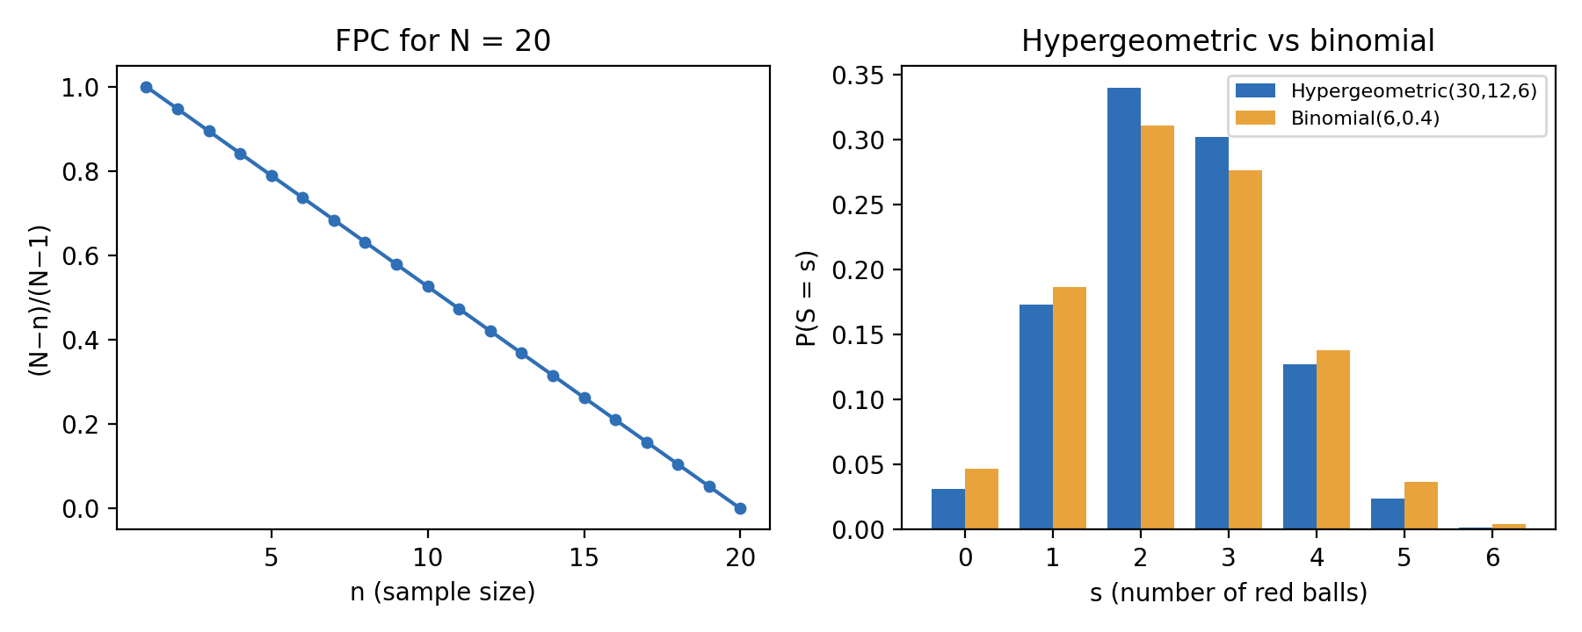
Figure 3. Left: FPC (N − n)/ (N − 1) for N = 20. Right: Hypergeometric (30, 12, 6) versus Binomial (6, 0.4).

4.4 The limit $N→∞$: the binomial distribution
Fix $n$ and $k$ and let $N,K→∞$ with $K/N→p$. Writing the hypergeometric pmf with falling factorials,
$$\frac{\left({K \atop k}\right)\left({N-K \atop n-k}\right)}{\left({N \atop n}\right)}=\left({n \atop k}\right) \frac{\left[K\left(K-1\right)⋯\left(K-k+1\right)\right] \left[\left(N-K\right)⋯\left(N-K-n+k+1\right)\right]}{N\left(N-1\right)⋯\left(N-n+1\right)}.$$
The numerator has $k$ factors of size $≈K$ and $n-k$ factors of size $≈N-K$; the denominator has $n$ factors of size $≈N$. Each factor $K-j$ (with $j$ fixed) satisfies $\left(K-j\right)/N→p$, and likewise $\left(N-K-j\right)/N→q$, $\left(N-j\right)/N→1$. Therefore
$$P\left(S_{n}=k\right)→\left({n \atop k}\right) p^{k}q^{ n-k}.$$
At the level of moments, $\frac{N-n}{N-1}→1$, so $Var\left(S_{n}\right)→npq$, and $ρ=-\frac{1}{N-1}→0$: the draws become asymptotically independent. Rule of thumb: when the sample is below about 5% of the population, the FPC is close to 1, and the binomial model is adequate. Check: $N=30$, $K=12$, $n=6$ (Figure 3, right) is already close to Binomial ($6$, $0.4$), though its variance $1.19$ is still smaller than $1.44$; at $n=N$ the variance is exactly 0.

5. Examples and interesting facts (Part E)

5.1 E1 — Worked example: inspecting chargers
Problem. A box holds $N=10$ phone chargers, of which $K=3$ are defective. An inspector takes 2 chargers at random without replacement. Let $X_{i}=1$ if the $i$-th charger is defective and $S=X_{1}+X_{2}$.
Joint pmf (multiplication rule). $P\left(X_{1}=x_{1},X_{2}=x_{2}\right)=P\left(X_{1}=x_{1}\right) P\left(X_{2}=x_{2}∣X_{1}=x_{1}\right)$:
Table 2. Joint pmf for N = 10, K = 3 (check: 42 + 21 + 21 + 6 = 90).
 | $$X_{2}=0$$ | $$X_{2}=1$$ | Total
$$X_{1}=0$$ | $$\frac{7}{10}⋅\frac{6}{9}=\frac{42}{90}$$ | $$\frac{7}{10}⋅\frac{3}{9}=\frac{21}{90}$$ | $$\frac{63}{90}$$
$$X_{1}=1$$ | $$\frac{3}{10}⋅\frac{7}{9}=\frac{21}{90}$$ | $$\frac{3}{10}⋅\frac{2}{9}=\frac{6}{90}$$ | $$\frac{27}{90}$$
Total | $$\frac{63}{90}$$ | $$\frac{27}{90}$$ | 1
(a) Joint probability. $P\left(X_{1}=1,X_{2}=1\right)=\frac{3}{10}⋅\frac{2}{9}=\frac{1}{15}≈0.067$. Meaning: both chargers are defective in about 6.7% of inspections; with replacement it would be ${0.3}^{2}=0.09$.
(b) Conditional probability and expectation. $P\left(X_{2}=1∣X_{1}=1\right)=\frac{6/90}{27/90}=\frac{2}{9}≈0.222$, which is also $E\left(X_{2}∣X_{1}=1\right)$. Meaning: if the first charger is defective, the chance that the second is too drops from $0.3$ to $0.222$, because only 2 defectives are left among 9 chargers. If the first charger is good, the chance rises to $P\left(X_{2}=1∣X_{1}=0\right)=\frac{21/90}{63/90}=\frac{1}{3}$.
(c) The sum. $S∼\text{Hypergeometric}\left(10,3,2\right)$: $P\left(S=0\right)=\frac{42}{90}=\frac{7}{15}$, $P\left(S=1\right)=\frac{21+21}{90}=\frac{7}{15}$, $P\left(S=2\right)=\frac{6}{90}=\frac{1}{15}$. Hence $P\left(S≥1\right)=\frac{8}{15}≈0.533$. Meaning: an inspection finds at least one defective charger in 53.3% of cases (with replacement: $1-{0.7}^{2}=0.51$).
(d) Moments of the sum. $E\left(S\right)=\frac{7}{15}+\frac{2}{15}=0.6=2p$. With $p=0.3$, $Cov\left(X_{1},X_{2}\right)=-\frac{0.21}{9}=-\frac{7}{300}$, $ρ=-\frac{1}{9}$, and $Var\left(S\right)=2\left(0.21\right)⋅\frac{8}{9}=\frac{28}{75}≈0.373$. Check from the pmf: $E\left(S^{2}\right)=\frac{7}{15}+\frac{4}{15}=\frac{11}{15}$ and $\frac{11}{15}-0.36=0.373$.

5.2 E2 — Data example (simulated)
Data. There are 60 independent experiments. In each, an urn with $N=6$ balls (balls 1–3 red, 4–6 blue) is emptied of two balls without replacement. The data are simulated, not real: Python numpy.random.default_rng(2026), rng.choice(6, size=2, replace=False); no real data set was used. The 60 pairs, the formulas and the generating code are in the attached workbook Topic5_E2_Data_Example.xlsx (sheets Parameters, Data, Analysis, Method) and in source/. Excel functions: AVERAGE, VAR.S, COVARIANCE.S, CORREL, COUNTIFS.
The exact values for $N=6$, $K=3$ from Parts A–B are $p=0.5$, $Var\left(X_{i}\right)=0.25$, $Cov=-\frac{0.25}{5}=-0.05$, $ρ=-\frac{1}{5}=-0.20$, and $p\left(0,0\right)=p\left(1,1\right)=0.2$, $p\left(0,1\right)=p\left(1,0\right)=0.3$.
Table 3. Sample statistics against the model (sample quantities $\overset{‾}{x}$, $s^{2}$, $s_{xy}$, $r$; model quantities are population values).
Quantity | Excel function | Sample ($n=60$) | Model
Mean ${\overset{‾}{x}}_{1}$ | AVERAGE | 0.550 | 0.500
Mean ${\overset{‾}{x}}_{2}$ | AVERAGE | 0.500 | 0.500
Variance $s_{1}^{2}$ | VAR.S | 0.252 | 0.250
Variance $s_{2}^{2}$ | VAR.S | 0.254 | 0.250
Covariance $s_{xy}$ | COVARIANCE.S | −0.042 | −0.050
Correlation $r$ | CORREL | −0.168 | −0.200
$P\left(X_{2}=1∣X_{1}=1\right)$ (empirical $14/33$) | COUNTIFS | 0.424 | 0.400
$P\left(X_{2}=1∣X_{1}=0\right)$ (empirical $16/27$) | COUNTIFS | 0.593 | 0.600

Table 4. Joint frequency table.
Cell $\left(x_{1},x_{2}\right)$ | (0,0) | (0,1) | (1,0) | (1,1)
Observed count | 11 | 16 | 19 | 14
Expected $n⋅p\left(x_{1},x_{2}\right)$ | 12 | 18 | 18 | 12
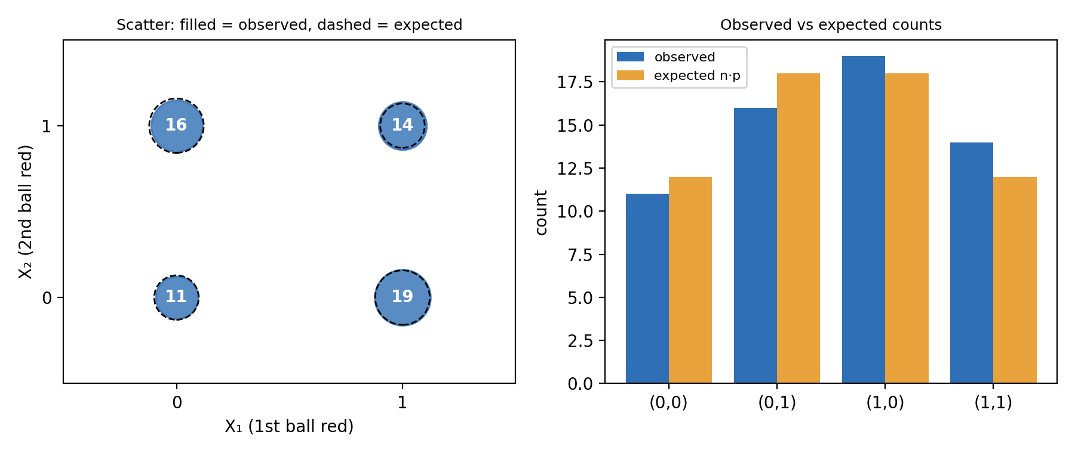
Figure 4. Left: scatter plot of the 60 pairs (the data take four values, so bubble area shows the count; dashed circles show the expected counts). Right: observed against expected frequencies.
Does the model describe the data? Yes, within what a sample of 60 can show. The sample correlation $r=-0.168$ is negative and close to $ρ=-0.20$; both conditional proportions lie on the correct side of $\frac{1}{2}$ in the model’s direction ($0.424<0.593$); and every cell count is within 2 of its expected value. The difference between ${\overset{‾}{x}}_{1}=0.55$ and $0.5$ is about 0.8 standard errors of a mean of 60 Bernoulli (0.5) values ($\sqrt{0.25/60}≈0.065$), so it is ordinary sampling variation. The sample is too small to separate $ρ=-0.2$ sharply from 0: that is a limit of the sample, not a flaw of the model. As a further check, the same simulation of 200,000 replications gives $r=-0.197$ and means $0.499$ and $0.500$, very close to the model values. (Formal estimation and testing belong to the second half of the course and are not used here.)

5.3 E3 — Interesting facts
1. History — Fisher’s lady tasting tea. In his book The Design of Experiments (1935), R. A. Fisher described an experiment in which a lady claims to tell whether milk or tea was poured first into a cup. She is given 8 cups, 4 of each kind, in random order, and must say which 4 were milk-first. The number of correct picks follows our model: it is Hypergeometric ($N=8$, $K=4$, $n=4$). There are $\left({8 \atop 4}\right)=70$ equally likely selections, so guessing all four correctly has probability $\frac{1}{70}≈0.014$, and getting at least 3 of the 4 right has probability $\frac{1+16}{70}=\frac{17}{70}≈0.243$. Fisher used the example to explain why randomisation and a calculable null distribution matter. Sources: Fisher (1935), chap. 2; Salsburg (2001).
2. History — de Finetti and exchangeability. Bruno de Finetti introduced exchangeability in 1931 and showed that an infinite exchangeable sequence of 0–1 variable is a mixture of independent Bernoulli sequences. Our pair is exchangeable ($P\left(x_{1},x_{2}\right)=P\left(x_{2},x_{1}\right)$) but not independent ($p\left(1,1\right)<p^{2}$); a finite urn is the standard example. De Finetti’s theorem needs an infinite sequence, which an urn is not. Diaconis and Freedman (1980) proved that a finite exchangeable sequence looks like a mixture of independent draws when the number of draws is small compared with the length of the sequence, which is our $N→∞$ limit of Section 4.4. Sources: de Finetti (1931); Diaconis and Freedman (1980).
3. Application with numbers — survey sampling. A survey asks $n=100$ people from a register of $N=500$. Treating the answers as independent overstates the standard error of the sample proportion by the factor $1/\sqrt{\left(N-n\right)/\left(N-1\right)}=\sqrt{499/400}≈1.117$. Equivalently the true standard error is $\sqrt{400/499}≈0.895$ of the naive one: about 10% smaller. This is the FPC of Section 4.2. Below 5% sampled (for example $n=100$ of $N=5000$, factor $0.990$) the correction can be ignored. Source: Cochran (1977), chap. 2.
4. Application with numbers — acceptance sampling. A lot of $N=100$ items contain $K=5$ defectives. The lot is accepted if a sample of 10 contains none. The exact hypergeometric probability of acceptance is $\left({95 \atop 10}\right)/\left({100 \atop 10}\right)≈0.584$; the binomial approximation ${0.95}^{10}≈0.599$ is slightly too optimistic because it ignores the negative dependence between draws. Source: Montgomery (acceptance sampling chapter).
5. Link to other models. (i) Topic 1: $\left(X_{1},X_{2}\right)$ is a pair of Bernoulli variables in a $2×2$ table with $p_{11}=\frac{K\left(K-1\right)}{N\left(N-1\right)}$, so $ρ=-\frac{1}{N-1}$ is their phi coefficient. (ii) Topic 3 and the binomial: the draws with replacement form the multinomial/binomial model; our hypergeometric model converges to it as $N→∞$. (iii) A lower bound: for $N$ exchangeable indicators $Var\left(X_{1}+…+X_{N}\right)=Nσ^{2}\left[1+\left(N-1\right)ρ\right]≥0$ forces $ρ≥-\frac{1}{N-1}$, and the urn attains this bound exactly (the sum of all draws is the constant $K$). Checks: $N=2$ gives $ρ=-1$; $N=52$ gives $ρ=-\frac{1}{51}≈-0.020$. Source: Ross, chap. 7.
6. Misconception — “the second card has a different chance”. This is false until the first card is seen. For a deck, $P\left(\text{2nd card is an ace}\right)=\frac{4}{52}⋅\frac{3}{51}+\frac{48}{52}⋅\frac{4}{51}=\frac{12+192}{2652}=\frac{1}{13}$, the same as for the first card. Only the conditional chance changes: $\frac{3}{51}$ after seeing an ace and $\frac{4}{51}$ after seeing a non-ace. The error comes from confusing the marginal with the conditional distribution (Section 1.4 versus 1.5). Source: Blitzstein and Hwang, chapters on conditional probability and indicators.

Sources
- Blitzstein, J. K. and Hwang, J. Introduction to Probability, 2nd ed., CRC Press, 2019 — conditional probability, indicator variables, sampling without replacement; pp. [add].
- Casella, G. and Berger, R. L. Statistical Inference, 2nd ed., Duxbury, 2002 — chapter on multiple random variables (joint, marginal, conditional distributions; covariance);
- Cochran, W. G. Sampling Techniques, 3rd ed., Wiley, 1977 — simple random sampling and the finite-population correction (chap. 2);
- de Finetti, B. “Funzione caratteristica di un fenomeno aleatorio”, Atti della R. Accademia Nazionale dei Lincei, 1931.
- Diaconis, P. and Freedman, D. “Finite exchangeable sequences”, Annals of Probability 8(4), 1980, pp. 745–764.
- Fisher, R. A. The Design of Experiments, Oliver and Boyd, Edinburgh, 1935 — chap. 2 (the lady tasting tea);
- Montgomery, D. C. Introduction to Statistical Quality Control, Wiley — chapter on lot-by-lot acceptance sampling for attributes (hypergeometric operating-characteristic curve); edition and pp.
- Mynbaev, K. AP Stats and Business Stats: Raising the Bar, KBTU, 2026 — course text.
- Ross, S. A First Course in Probability — chapters on random variables (hypergeometric), jointly distributed random variables and properties of expectation (covariance); chapter numbers as in the edition used;
- Salsburg, D. The Lady Tasting Tea, W. H. Freeman, 2001; pp.
- Watts, V. Introduction to Statistics: An Excel-Based Approach — Excel functions for E2; pp.
- Team files: Topic5_E2_Data_Example.xlsx, source/sim.py, source/data_60_pairs.csv.

